Wenjie **Lab 5**

1. What is your computers IP address? (This is not included in your traceroute results). Take a screenshot of your computers IP address.

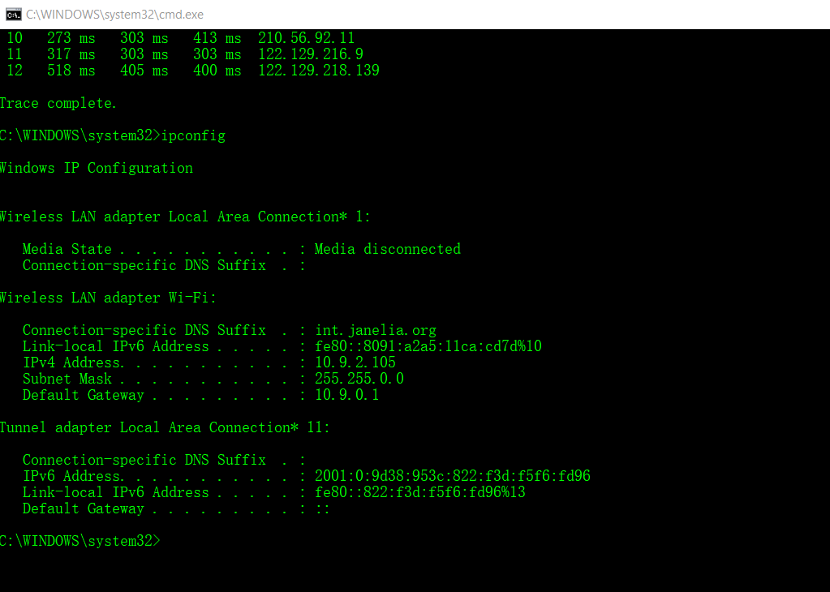Answer: My computer’s IP address is 10.9.2.105

2. With reference to private/public IP addresses. What type of IP address is the first IP from your traceroute result.

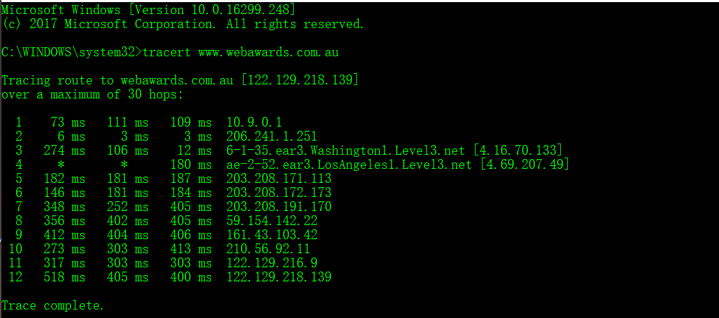Answer: The first IP is 10.9.0.1. It is private A.

3. With reference to private/public IP addresses. What type of IP address is the second IP from your traceroute result.

Answer: The second IP is 206.241.1.251. It is public.

4. In a tabular format (use table example below), and in sequential order. Indicate the location of each IP address (include state for US states) and the organization that owns the IP address. (Use https://www.ultratools.com/tools/ipWhoisLookup to look up IP address whois information).

|  |  |  |  |
| --- | --- | --- | --- |
| Hop Count | IP address | Organization (IP Owner) | Location (US state)/Country |
| 1 | 10.9.0.1 | Internet Assigned Numbers Authority | CA/US |
| 2 | 206.241.1.251 | Howard Hughes Medical Institute | MD/US |
| 3 | 4.16.70.133 | Level 3 Communications, Inc. | CO/US |
| 4 | 4.69.207.49 | Level 3 Parent, LLC | LA/US |
| 5 | 203.208.171.113 | Singapore Telecommunications Pte Ltd | Singapore |
| 6 | 203.208.172.173 | Singapore Telecommunications Pte Ltd | Singapore |
| 7 | 203.208.191.170 | Singapore Telecommunications (SINGTEL Internet Exchange) | Singapore |
| 8 | 59.154.142.22 | ORG-SOPL2-AP/SingTel Optus Pty Ltd | AUSTRALIA |
| 9 | 161.43.103.42 | ORG-SOPL2-AP/SingTel Optus Pty Ltd | AUSTRALIA |
| 10 | 210.56.92.11 | ESCAPENET | AUSTRALIA |
| 11 | 122.129.216.9 | ORG-WPPL1-AP/Web Prophets Pty Ltd | AUSTRALIA |
| 12 | 122.129.218.139 | ORG-WPPL1-AP/Web Prophets Pty Ltd | AUSTRALIA |



5. In your own words, explain everything you just did, and what route did your packet took from source to destination. How many US states did your packet go through? How many countries if any?

Answer: I typed ‘tracert [www.webawards.com.au](http://www.webawards.com.au)’ in cmd.exe to record sequentially 12 hops of the entire routing path from source (IP 10.9.2.105) to destination (IP 122.129.218.139). The route my packet took went through 4 states in USA and three countries including USA, Singapore, and Australia.

Traceroute tool shows the name of the system (as determined from DNS), the system's IP address, and three round trip times.

In the terms of the process of calculating time each hop took, traceroute can send out 3 packets with the IP header indicating TTL(Time-to-Live). Three columns in one hop corresponds to the time that took to take one packet back (round-trip-time).

In my case, there were steps in the as follows:

1. When I executed the command ‘tracert www.webawards.com.au’, my computer sent out 3 UDP packets with a TTL of 1.

2. When the 3 UDP packets reach the 1st router (10.9.0.1), the router decreased the TTL to 0 and destroyed the packet. The reason is that the TTL value of an IP datagram is decremented by a value of one each time the packet is forwarded by a network device.

3. The 1st router (10.9.0.1) sent back to my computer with an ICMP Type 11, Code 0 Time Exceeded message.

4. My computer then knew the address of the 1st router in the path, because the ICMP message had a source address of the 1st router.

5. Next my computer repeated the above steps for the 2nd router (206.241.1.251). The difference is the new UDP packets specified with a TTL of 2. So, the 1st route reduced the TTL to 1, and the 2nd router reduced the TTL to 0. The 2nd router dropped the packets and sent back same ICMP massage with the source IP of the 2nd router to my computer. Thus, my computer knew the 2nd router in the path.

6. step 1-4 kept going with the TTL value in the IP header of each UDP packets incrementally until reaching the destination device (IP 122.129.218.139).

7. when the last UDP packets reached the destination, the packets wanted to connect to the destination port which was uncommon. The destination devise rejected the packets with an ICMP Type 3, Code 3 message sent to my computer. Then my computer understood this as the last hop, therefore traceroute will complete.

